
http://iringtools.org

iRINGTools Initial Setup Guide

Version 1.00.00

iRINGTools Initial Setup Guide

To build the code
- Install IIS on the machine
Go to Control Panel → Programs and Features → Turn Windows Features On or Off.
Check that following options are checked under Internet Information Services and click OK.

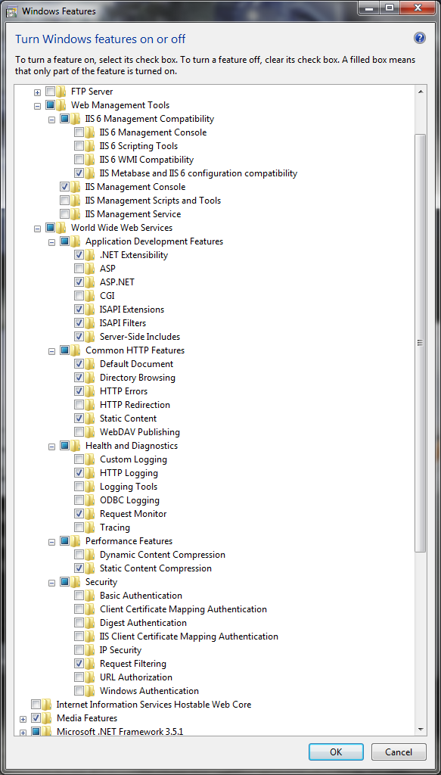

- Install .Net 3.5 SP1 on the machine
- Install svn client from the link http://subversion.tigris.org/servlets/ProjectDocumentList?folderID=8100
- Take the latest code from svn using command line ”svn checkout <url>”. <url> for iRing code base is https://iring-tools.googlecode.com/svn/trunk/ . If the code has already been checked out then run the command “svn update” to update the code with latest copy
- Install MSBuildTaks from the link http://msbuildtasks.tigris.org/
- Install Silverlight 3 SDK from the link http://www.microsoft.com/downloads/details.aspx?familyid=1EA49236-0DE7-41B1-81C8-A126FF39975B&displaylang=en
- Install Microsoft Silverlight Toolkit from the link http://silverlight.codeplex.com/Release/ProjectReleases.aspx?ReleaseId=24246
- Copy App_Default.config into a new file App.config for DBDictionaryUtil present at iring-tools\Utilities\DBDictionaryUtil\DBDictionaryUtil
- Copy App_Default.config into a new file App.config for QMXFGenerator present at iring-tools\Utilities\QMXFGenerator\QMXFGenerator
- Install SQL Server 2008 (Refer iRingTools Installation Guide for steps to install SQL Server 2008)
- Copy Web_Default.config into a new file Web.config for InterfaceService present at iring-tools\InterfaceService
- Host InterfaceService in IIS
- Copy Web_Default.config into a new file Web.config for AdapterService present at iring-tools\Adapter\AdapterService
- Host AdapterService in IIS
- Try to browse AdapterService, if it gives a problem, check that WCF is registered with IIS7. In order to check this, go to Control Panel → Turn Windows Features On or Off → Microsoft .NET Framework 3.5.1 → Check Windows Communication Foundation HTTP Activation
- Build the code by running build.cmd in iring-tools folder on the command prompt

To make changes in code

- Install Visual Studio 2008 with SP1
- Install Silverlight 3 Tools for Visual Studio 2008 SP1 from the location http://www.microsoft.com/downloads/details.aspx?familyid=9442B0F2-7465-417A-88F3-5E7B5409E9DD&displaylang=en
- Open the code by clicking iring-tools.sln present in iring-tools folder

